**Creating An Sponsored Post For Instagram**

**Project Description:**

Prepare to take Instagram by storm with our attention-grabbing sponsored post. We'll craft a visually stunning masterpiece that showcases your product or service, accompanied by a compelling caption that tells your brand's story and entices engagement. Our strategic use of hashtags and precise audience targeting will ensure your post reaches the right people. With a keen eye on performance metrics, we'll optimize the campaign for maximum impact. Let's collaborate and make your Instagram dreams a reality.

**Navigation:**

Navigate to https://www.canva.com/design/DAFw3s-OlXs/VDJd3BXrhnaXG7hd6e3nKg/edit?utm_content=DAFw3s-OlXs&utm_campaign=designshare&utm_medium=link2&utm_source=sharebutton

### Choose Any Format

### 

**Click Design And Search Templates Using Keywords**

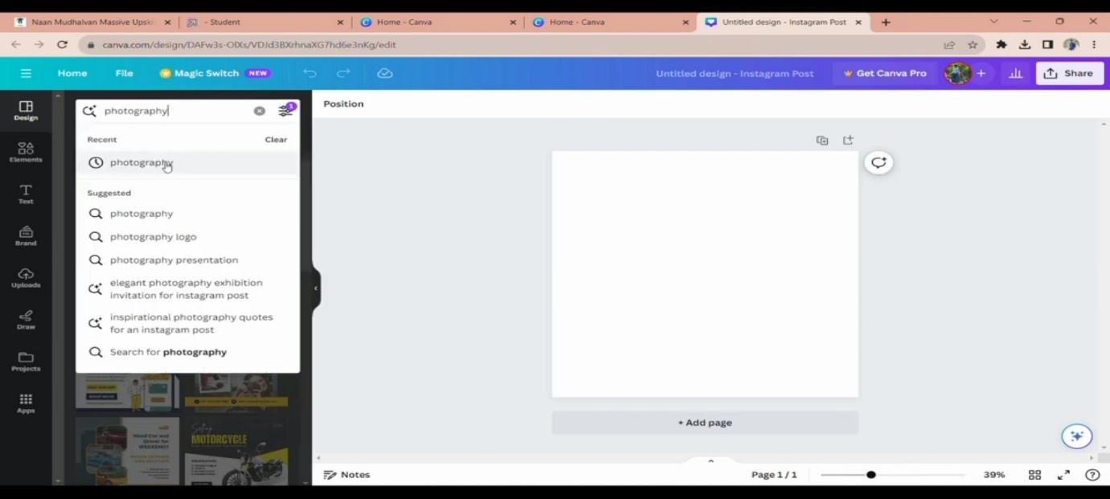

**Choose A Template**

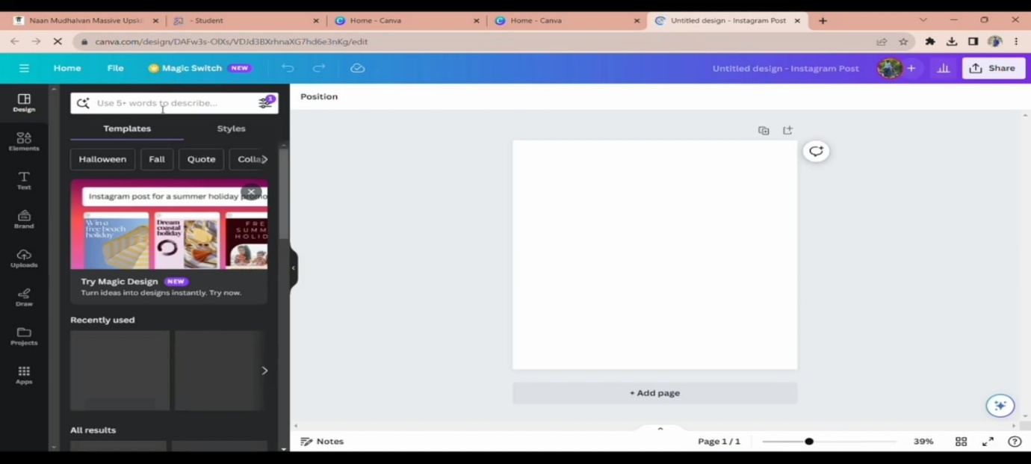

**Click "Uploads"**

### 

**Upload - Logo**

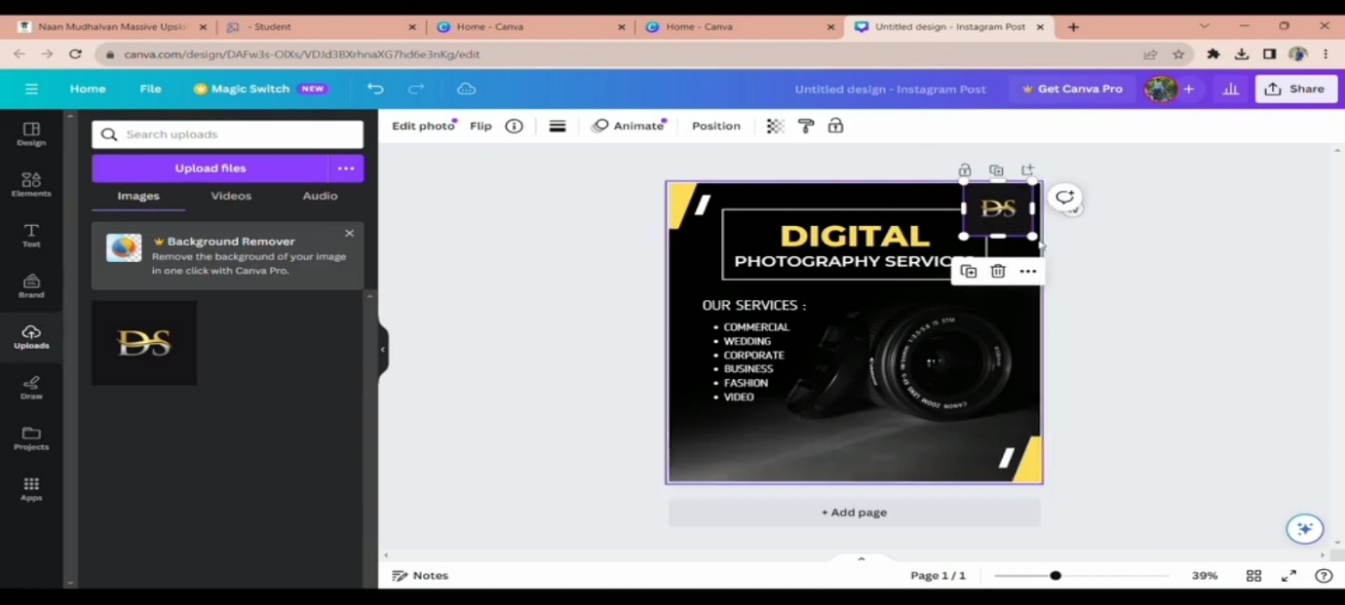

### Add Your Logo To The Poster

### 

**Click The Logo And Resize**

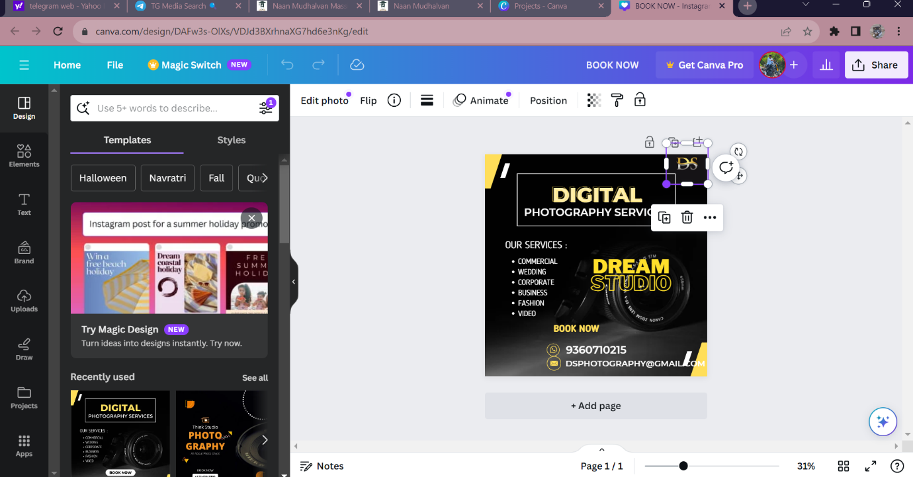

**Select The Contents**

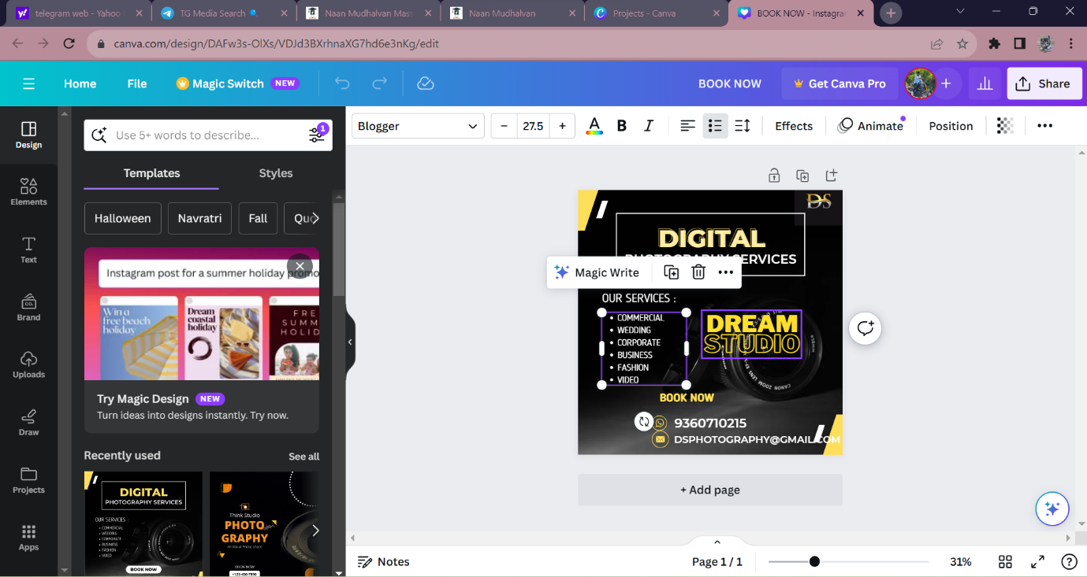

**Click "Effects" To Add Styles To Your Content**

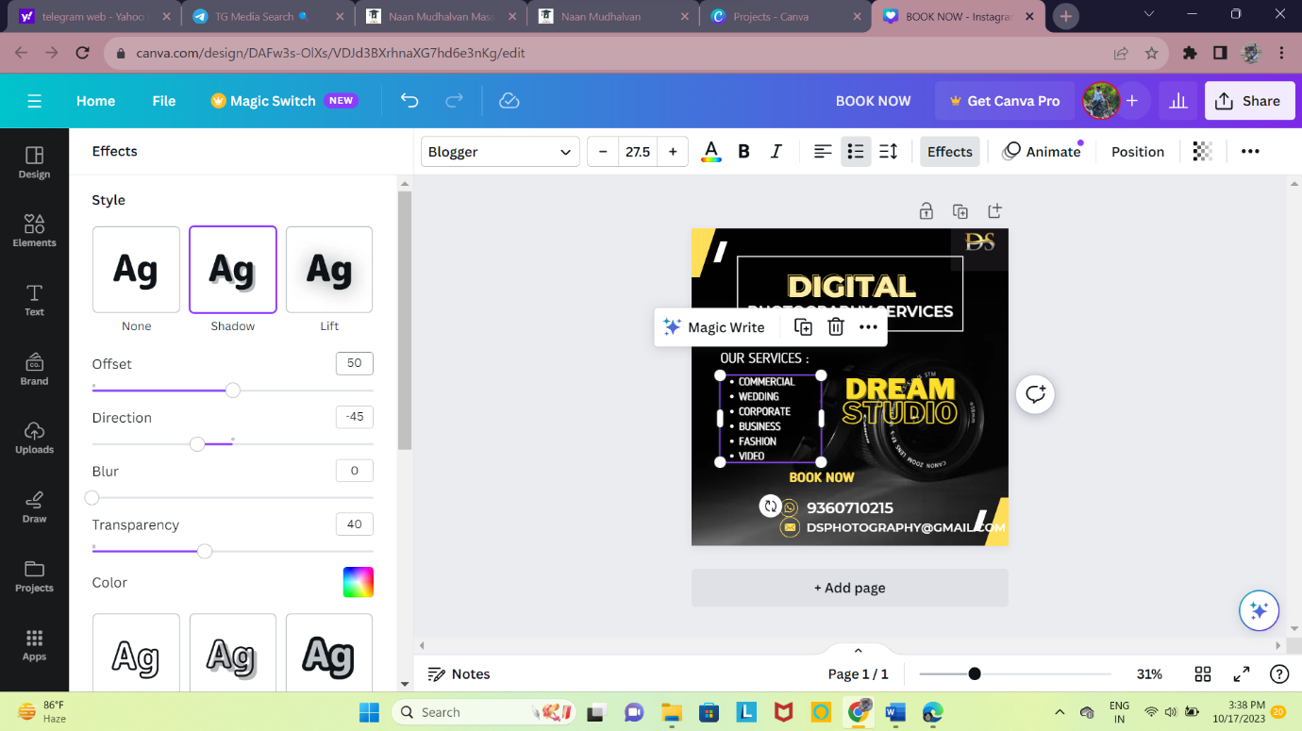

**Pick A Style And Select It**

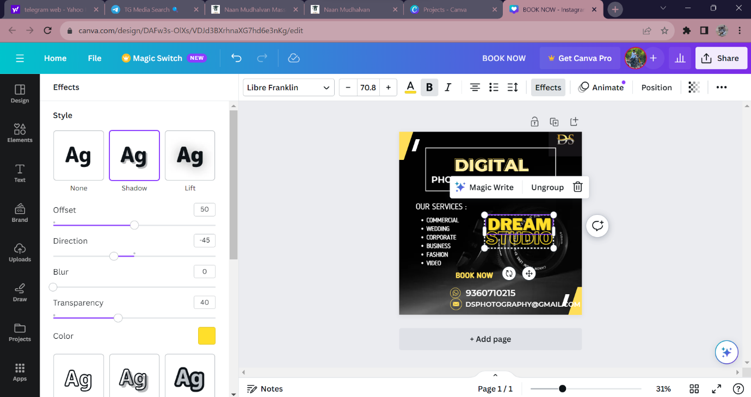

### Click Elements Icon To Add Different Icons, Images, Graphics Etc

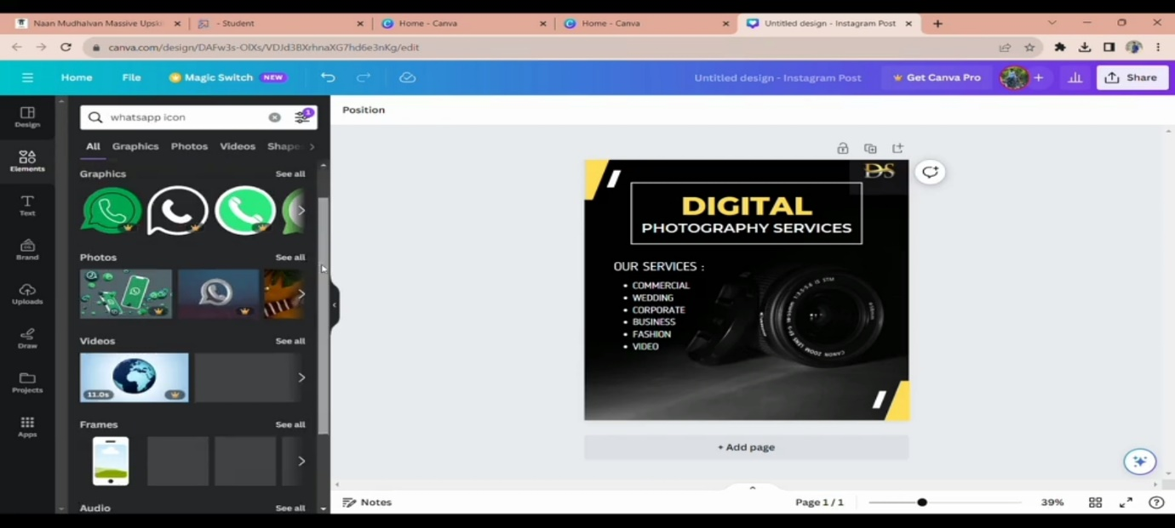

### Search What You Want And Select It

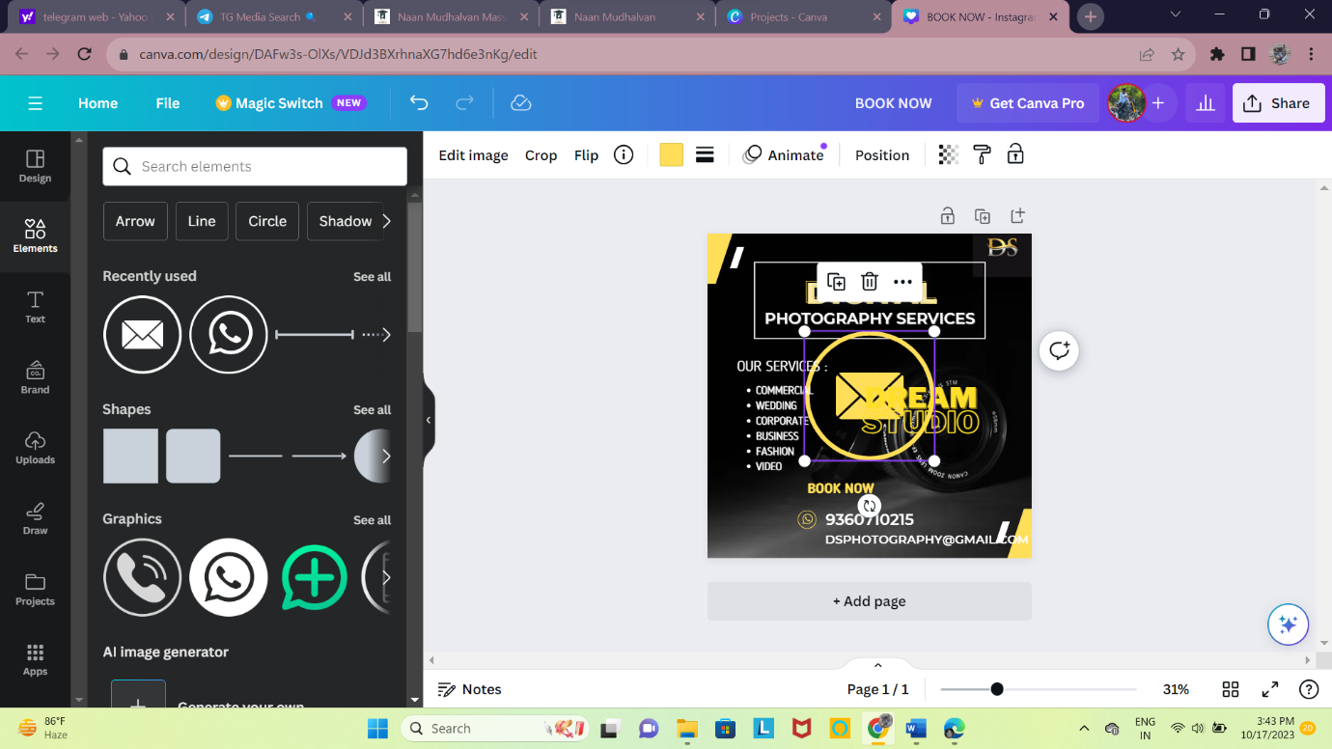

### Click "See All" To See All The Graphics And Pick One You Want

### 

### Select The Text And Choose A Font Style Of Your Liking

### 

### Click This Icon To Duplicate It

### 

### Select The Duplicated Text And Edit It

### 

### Select This To Change The Size Of The Text

### 

### Change It Upper Case Or Lower Case

### 

### Edit The Elements On The Design

### 

### Selecting The Multiple Elements

### 

### Letter Spacing & Line Spacing

### 

### Changing The Colour Of The Font

### 

### Select The Graphics You Need

### 

### Resize It

### 

### Place It Where You Need

### 

### Add Your Contents

### 

### Adjust The Length If You Need

### 

### Add Your Own Contents

### 

### Click This Icon

### 

### Click "Download"

### 